Mid Term Task

Part I

1. Host a static website on Blob Storage: build and deploy a static Hello

World website to Azure Storage.

2. Verify that the default web page has the **Hello World!** page.

3. Provide the steps and results.

This is the URL of the default web page :   
https://hello-page-danieljovevski.azurewebsites.net/

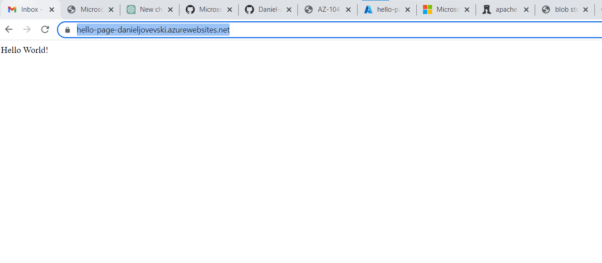

Steps that I’ve made:

1. Created new app service with new resource group, with a globally unique name.

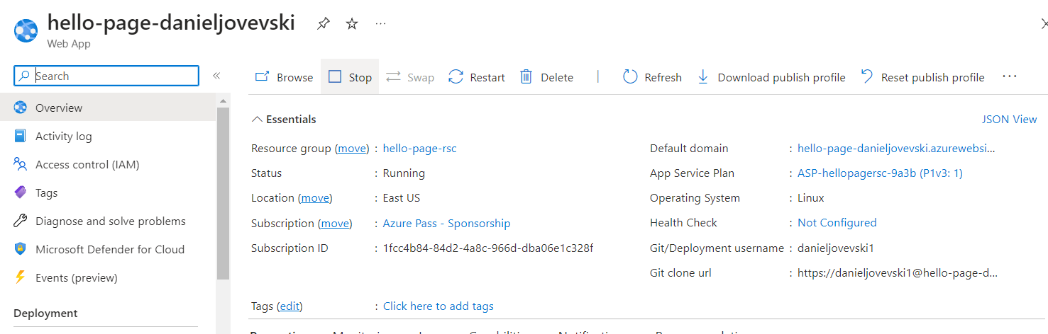

1. In deployment center configured username and password.

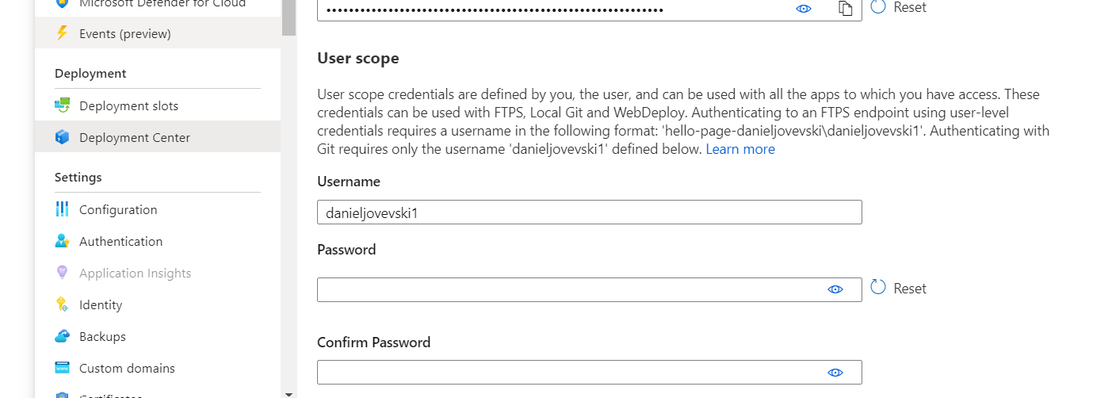

1. Used the git resources from the homework with the web apps.
2. Deployed the code to the deployment slot.

The domain webapp is still active if it is needed to check.

**Part II**

1. Create a Virtual Network where you will deploy your Linux Based

Web Server.

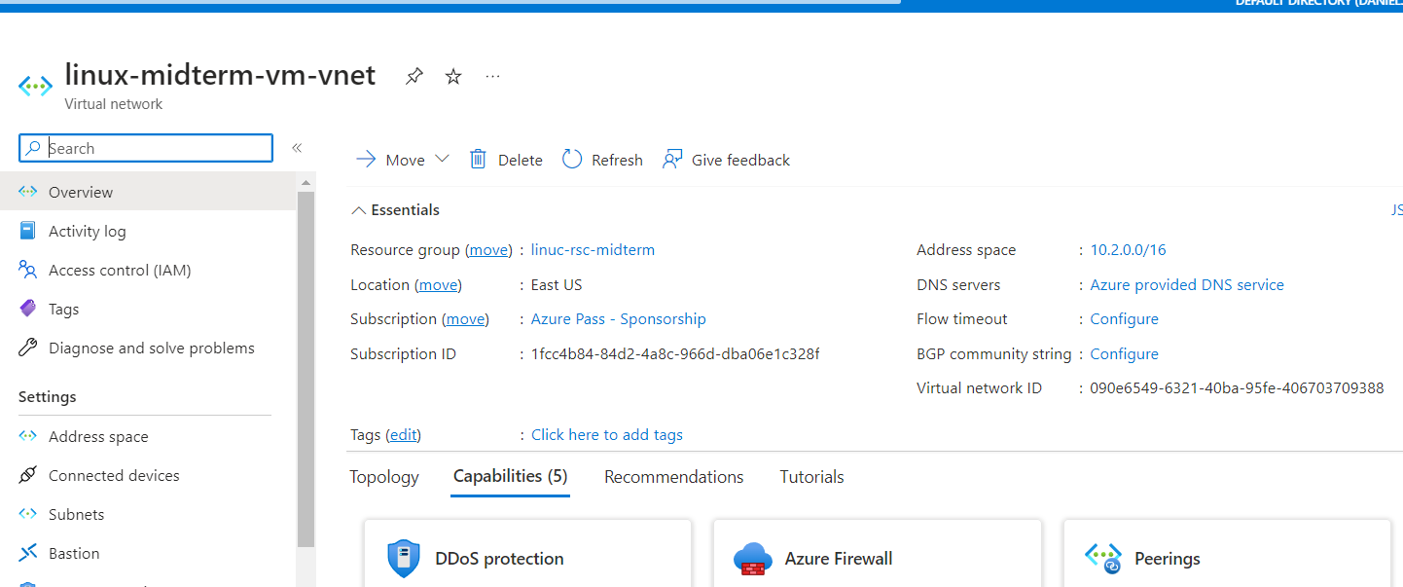

2. Modify the network security group for your virtual machine that will

allow you to remotely manage your machine only from your local

machine and nowhere else.  
- Adding inbound rule that the server can be remotely managed only from my IP address with SSH.   
- Adding inbound rule that the Web Server is publicly available for web publishing only from my local address.

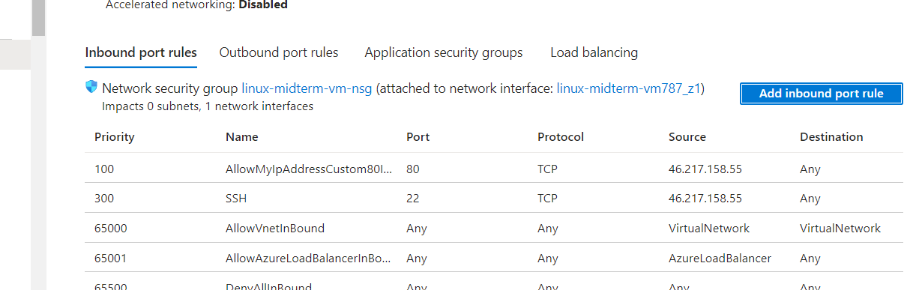

3. Create a Linux Virtual Machine that will be your Web Server which is

publicly available for web publishing (not SSL) only from your

machine and nowhere else.

- It has an inbound rule that the Web Server is publicly available for web publishing only from my local address.

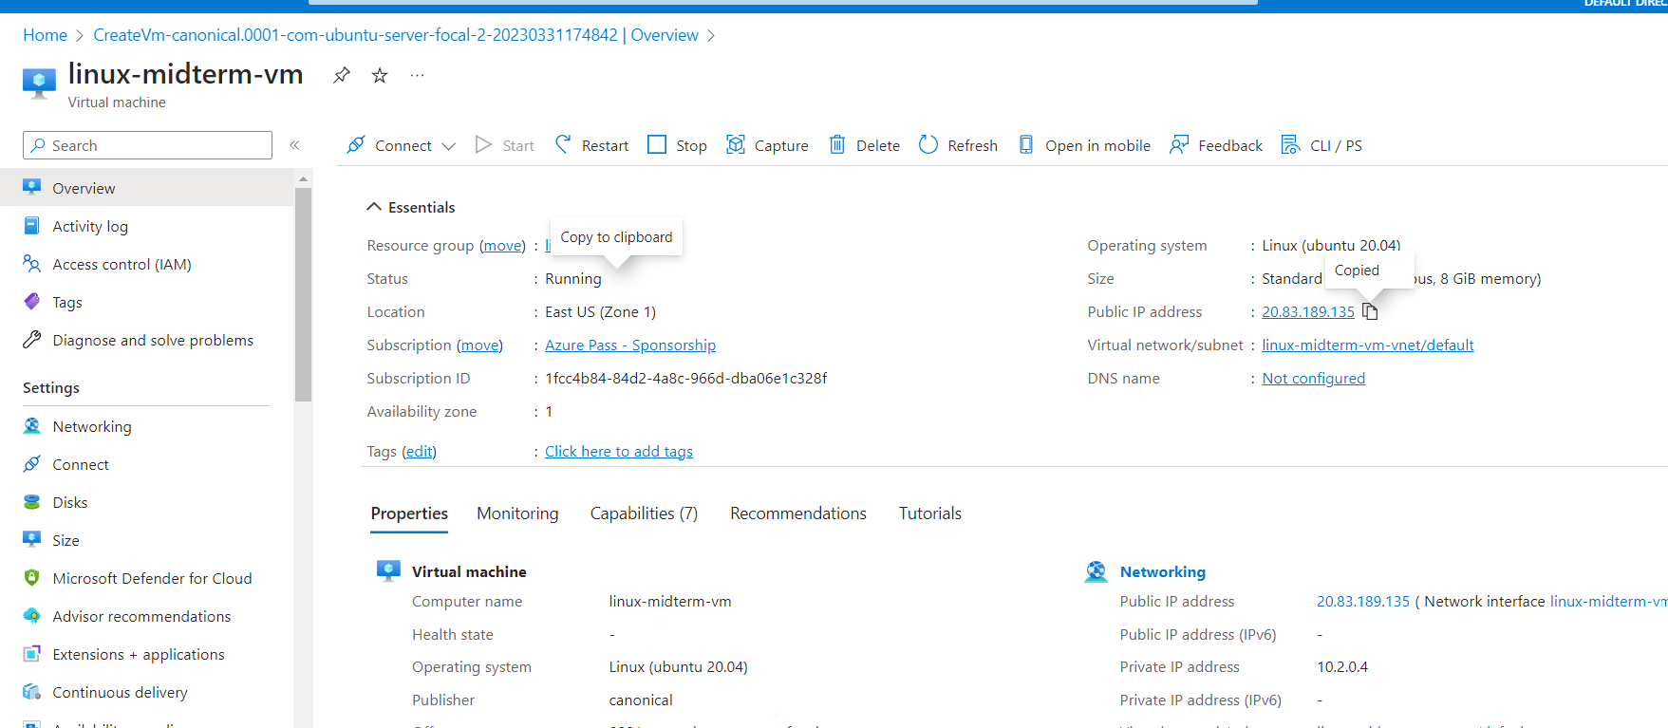

1. Connect to the VM.

Connected with SSH via terminal with username and password authentication.

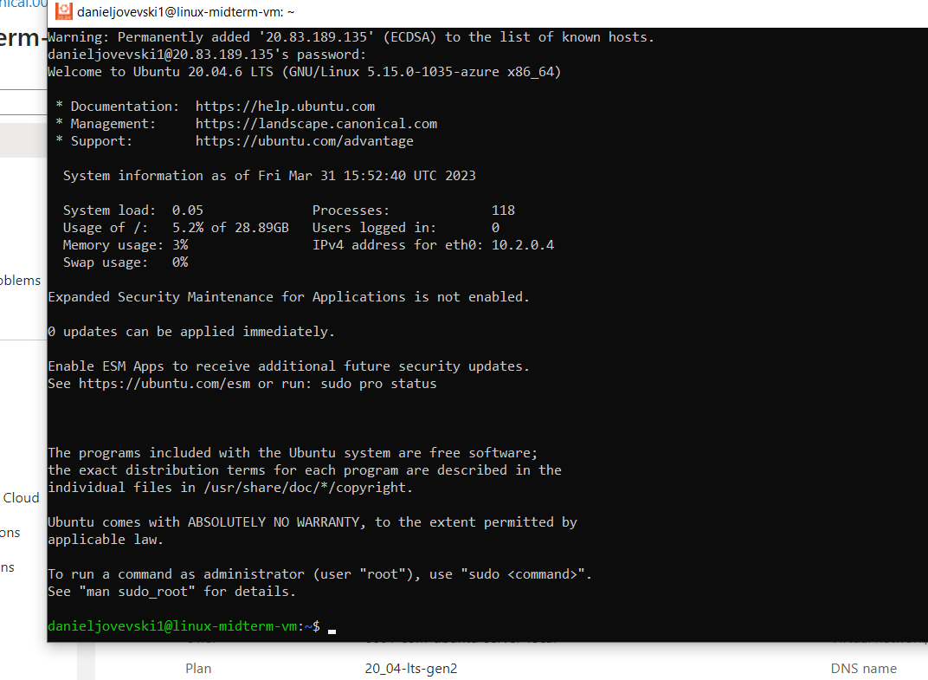

1. Install Apache Web Server.

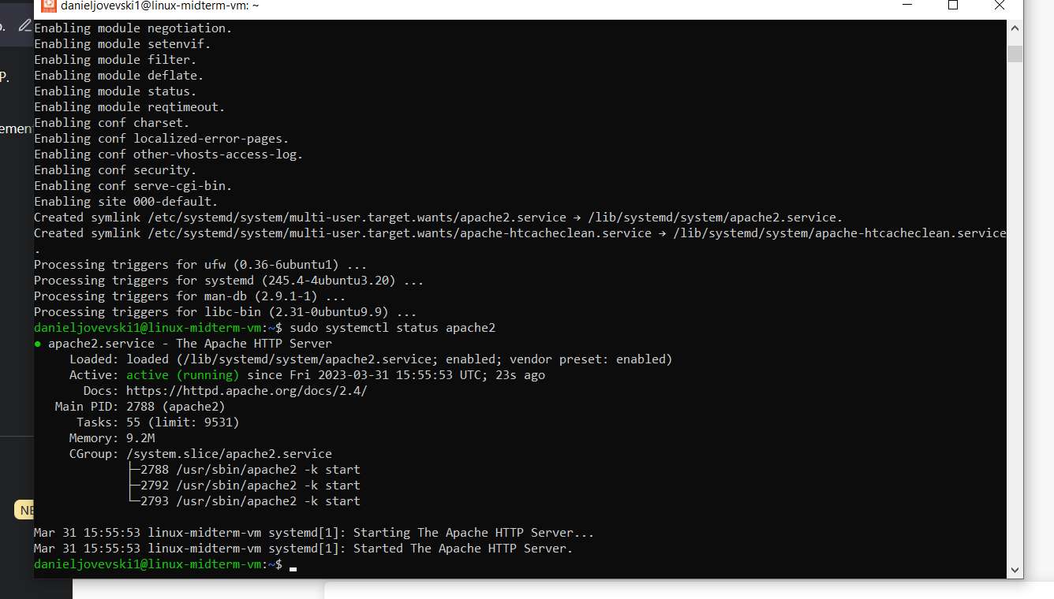

1. Deploy the “Hello World” web page.

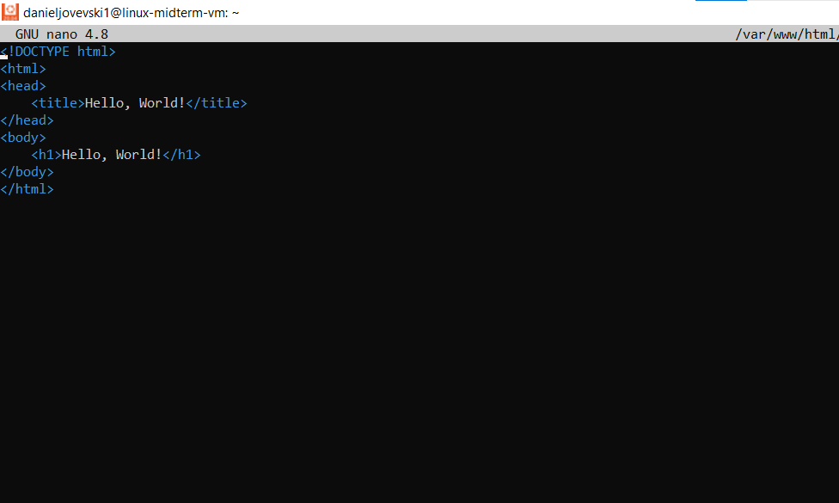

From my machine with my ip the site is reachable and it shows the hello world web page.

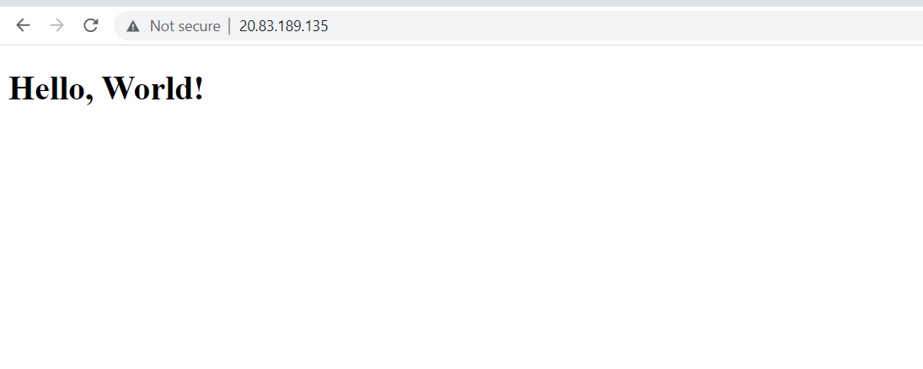

1. Provide Testing from your cellphone.

I can connect from my machine with my IP address, but on phone using 4G with other IP address, the site is not reachable.

